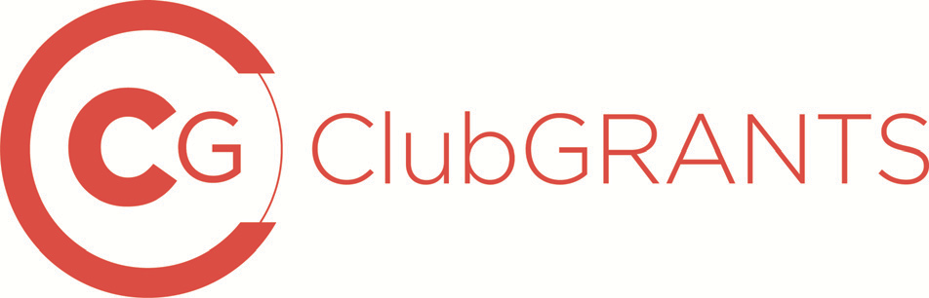

LETTER OF OFFER FOR FUNDING $7,500 AND ABOVE

Terms and conditions of funding

The provision of funds from the [insert name of club] is subject to a number of terms and conditions that must be agreed to by the recipient prior to the release of the funds.

Details of the terms and conditions are provided below. If the recipient is prepared to accept these terms and conditions, please sign this letter and return it to [name of club] within 14 days of receipt. Please retain a copy of this letter for your records.

- The recipient acknowledges that the funding of $[……] has been approved to undertake
[insert project activity] under the ClubGRANTS Scheme.

- The recipient acknowledges that the funds provided must be completely expended on the funded project by [insert deadline]. If the project has not commenced or been completed by this date, the [insert name of club] may require repayment of the funding or any unspent balances at its discretion.

- Any variation to the project, as detailed in the ClubGRANTS application form, must be agreed to in writing by the [insert name of club] and [insert name of recipient].

- The recipient agrees that access to the funding can only be obtained by signing and returning these terms and conditions of funding within 14 days.

- If, for whatever reason, the recipient is unable to proceed with the funded project, the recipient will inform the [insert name of club] as soon as possible in writing and immediately repay the funding to the [insert name of club].

As considered appropriate by the donating club, the recipient should provide reports on the use of the ClubGRANTS funds provided. The donating club should consider the funding amount and the nature of the project when assessing if one (or more) of the following reporting requirements (a)-
(e) would be preferable.

- The recipient will provide the [insert name of club] with:
  - Quarterly and/or annual progress reports on the funded project, and at any time on request by the [insert name of club].
  - Audited Financial Statement of the final costs within three months of the end of the recipient’s financial year in which the funded project is completed.

ClubGRANTS
LETTER OF OFFER FOR FUNDING $7,500 AND ABOVE

  - An operating statement (Income and Expenditure Statement) together with a signed Statement of Compliance within one month of completion of the funded project.
  - A Certificate of Acquittal within one month of completion of the funded project.
  - A brief written report on the achievements of the project against agreed objectives and/performance indicators within one month of completion of the funded project.

- Any advertisement or public acknowledgement of the funding made by the recipient will carry words to the effect that the ClubGRANTS scheme is a shared State Government-Club Industry program, funded by a 2.25% gaming machine tax rebate provided by the State Government to those registered clubs with gaming machine profits in excess of $1 million per annum.

- If the recipient breaches any of these terms and conditions, the [insert name of club]
reserves the right to withhold or reclaim in part or in whole the funding at its discretion.

Signature (recipient organisation)
Name/position of signatory
ABN of recipient organisation (if applicable)
Signature (club) Name/position of signatory Date
Sign and date one copy of this letter and retain it for your records.
Sign and date another copy of this letter and return it to the registered club.

Important information regarding GST

A non-profit organisation or donating club does not have a GST liability provided the non-profit organisation is not making a supply to the donor club in relation to the receipt of the payment. The acknowledgement of the funds provided in the recipient’s newsletter or annual report, or in a local state or national newspaper, or a certificate, plaque or equivalent of appreciation is not considered to be a supply from a recipient to a donor club.

